AIM: Develop a design of a mobile (or) web application to change background and menu

PROCEDURE:

1. Open Figma and create a new file

2. Set up frames of different screen sizes

3. Gather Resources

4. Start with outline to a low defined basic structure

5. Include all essential components like logo search bar etc   
6. Refine the design ensuring all the elements are pixel perfect

7. Change the Background and menu

8. Export the design assets for development

BEFORE CHANGING BACKGROUND

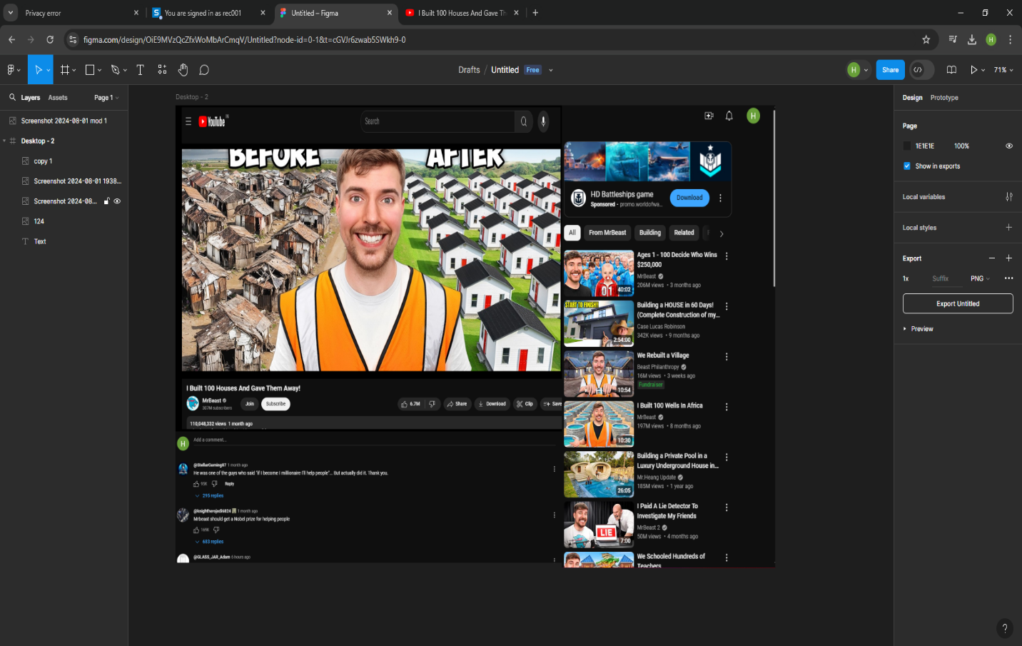

AFTER CHANGING BACKGROUND

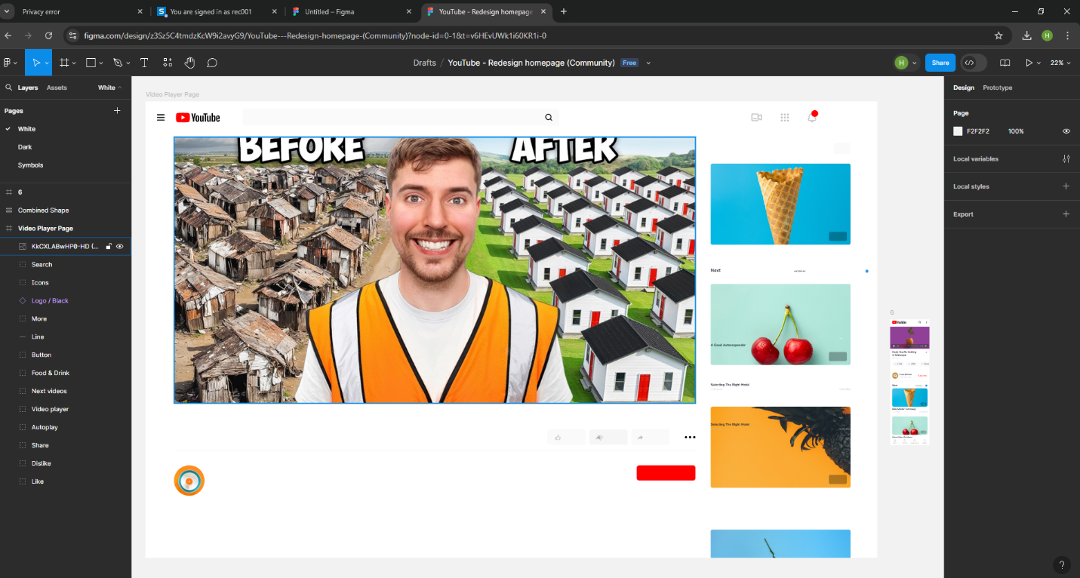

RESULT : The experiment is done and the output is verified